

Cloud Computing
BSE-VB
Submitted By
Tooba Shafique (2023-BSE-065)
Submitted to
Sir Shoaib
LAB-08
Task 1 — Create an AWS account and enable UAE (me-central-1)
Step 1: Open AWS Signup Page
Screenshot: task1_open_signup_page.png
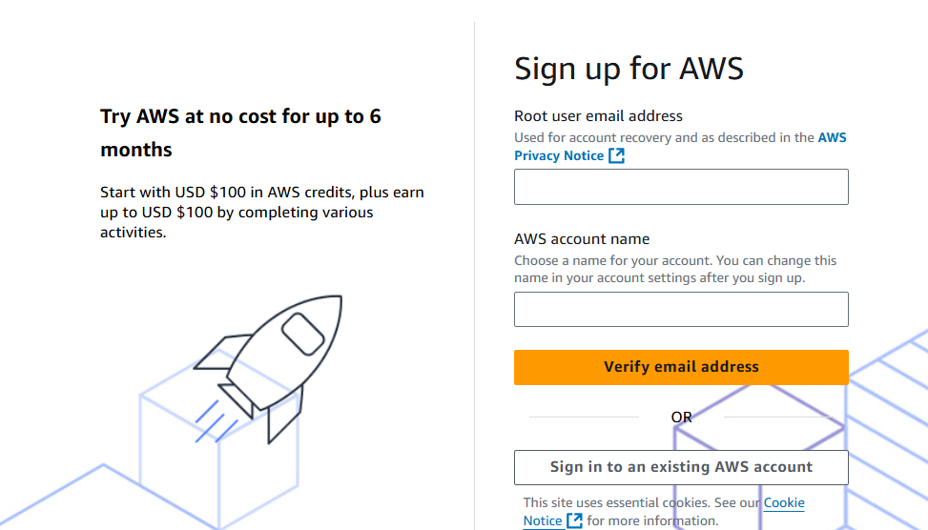
Step 2: Complete Registration
Screenshot: task1_signed_up_confirmation.png
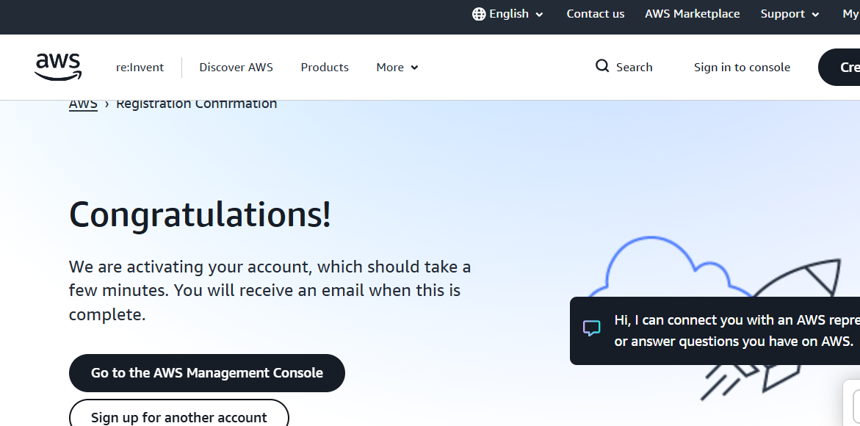
Step 3: Sign in as Root User
Screenshot: task1_root_signed_in.png
Step 4: Enable UAE Region (me-central-1)
Screenshot: task1_enable_region_me-central-1.png
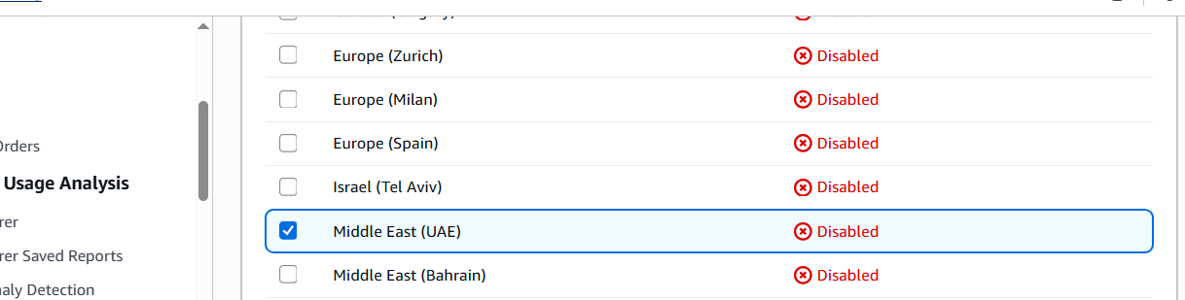
Step 5: Task 1 Summary — root console header + region active
Screenshot: task1_summary.png
Task 2 — Create IAM Admin and Lab8User with Console Access
Goal: Create Admin IAM user, then Lab8User, both with AdministratorAccess.
Step 1: Open IAM Console
Screenshot: task2_open_iam_console.png
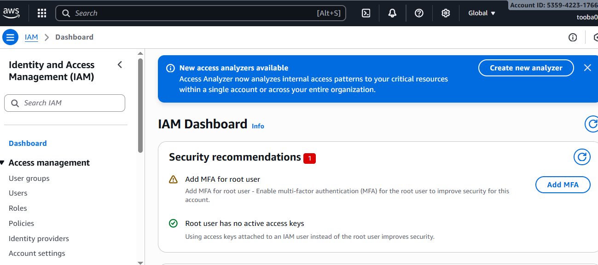
Step 2: Create Admin User (console access + AdministratorAccess)
Screenshot: task2_admin_create_confirmation.png
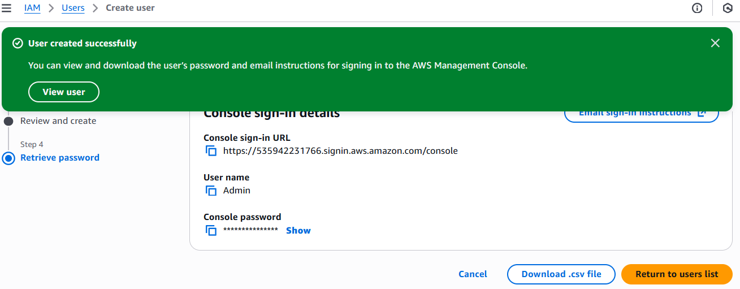
Step 3: Download Admin CSV and show on host
Screenshot: task2_admin_csv_and_signin_url.png
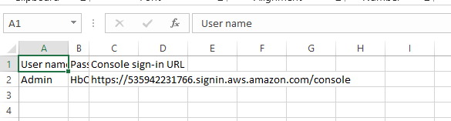
Step 4: Sign in as Admin
Screenshot: task2_admin_console_after_login.png
Step 5: Create Lab8User (console access + AdministratorAccess)
Screenshot: task2_create_lab8user_and_csv.png
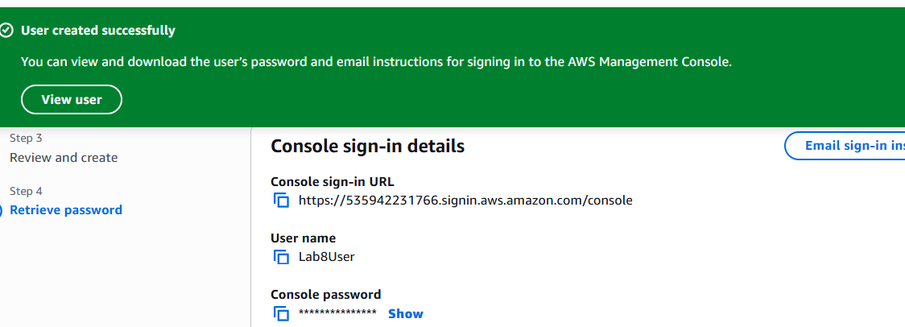
Step 6: Download Lab8User CSV on host
Screenshot: task2_lab8user_csv_saved.png
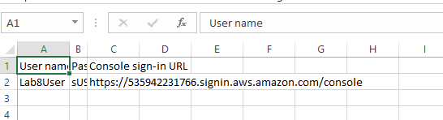
Step 7: Sign in as Lab8User
Screenshot: task2_lab8user_logged_in.png
Step 8: Task 2 Summary — show both IAM users
Screenshot: task2_summary.png
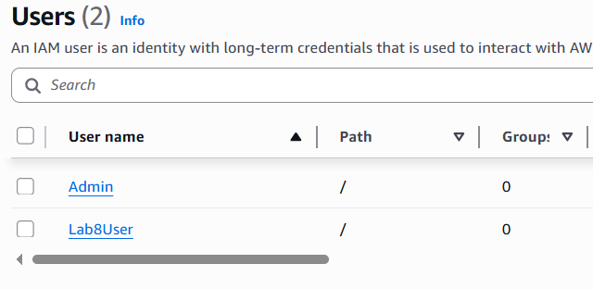

Task 3 — Inspect VPC Resources (me-central-1)
Goal: View counts of VPCs, Subnets, Route Tables, and Network ACLs in me-central-1.
Step 1: Open VPC Console
Screenshot: task3_open_vpc_console.png
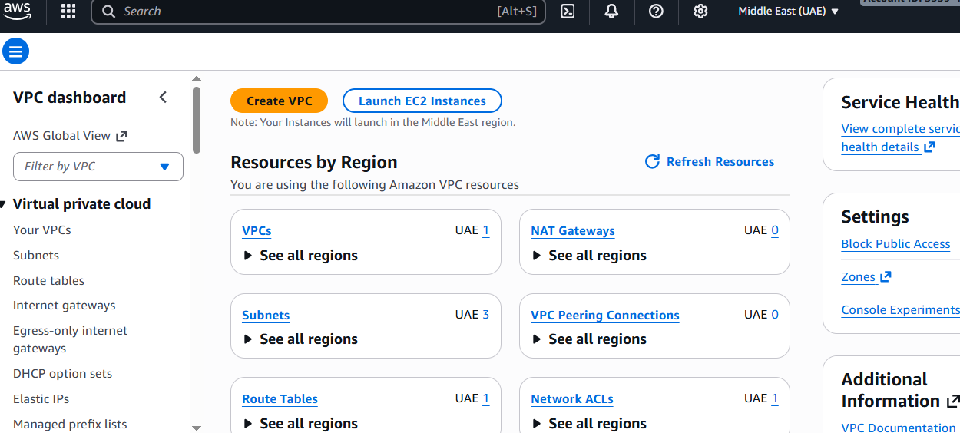
Step 2: View VPCs List
Screenshot: task3_vpcs_list.png
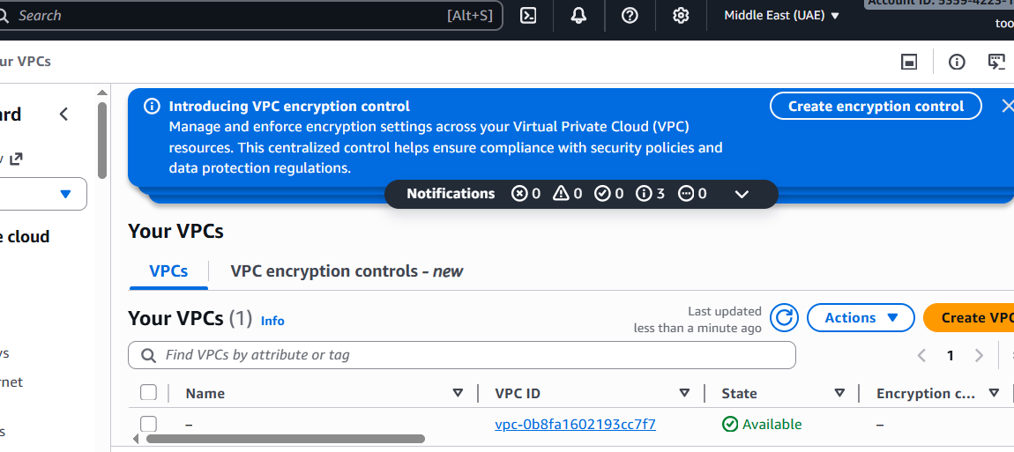
Step 3: View Subnets List
Screenshot: task3_subnets_list.png
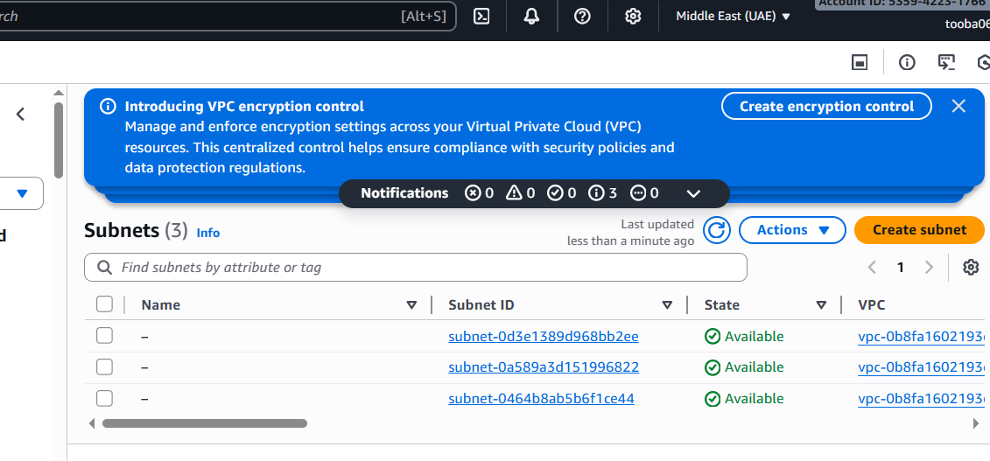
Step 4: View Route Tables List
Screenshot: task3_route_tables_list.png
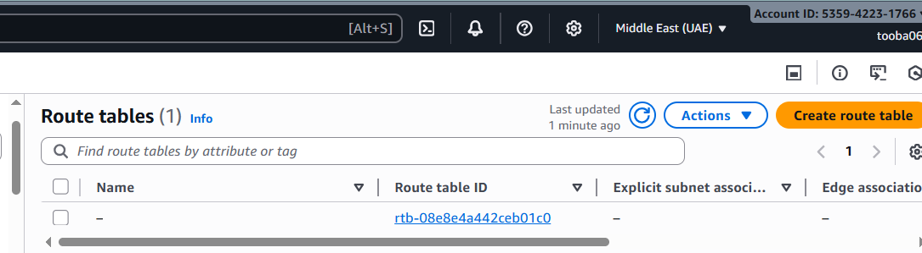
Step 5: View Network ACLs List
Screenshot: task3_network_acls_list.png
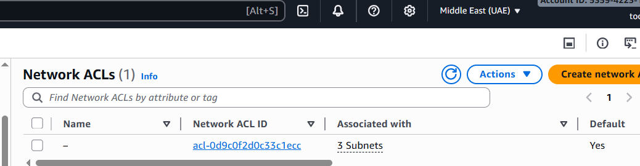
Step 6: Task 3 Summary — single screenshot showing all resources
Screenshot: task3_summary.png
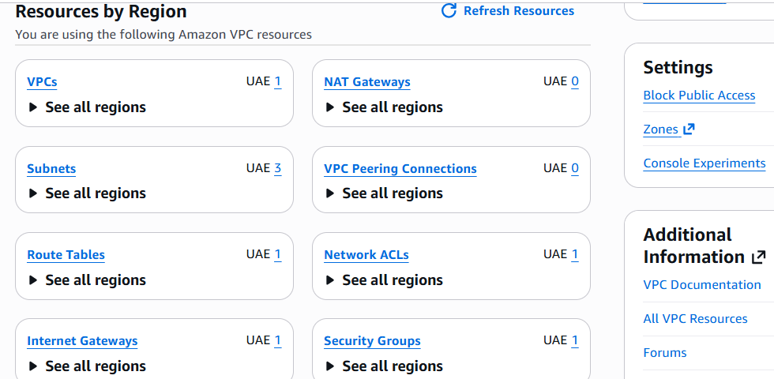

Task 4 — Launch EC2, SSH, Install Docker & Docker Compose, Deploy Gitea
Goal: Launch EC2 instance Lab8Machine, configure security, install Docker/Docker Compose, deploy Gitea, allow port 3000.
Step 1: Open EC2 Console (me-central-1)
Screenshot: task4_open_ec2_console.png
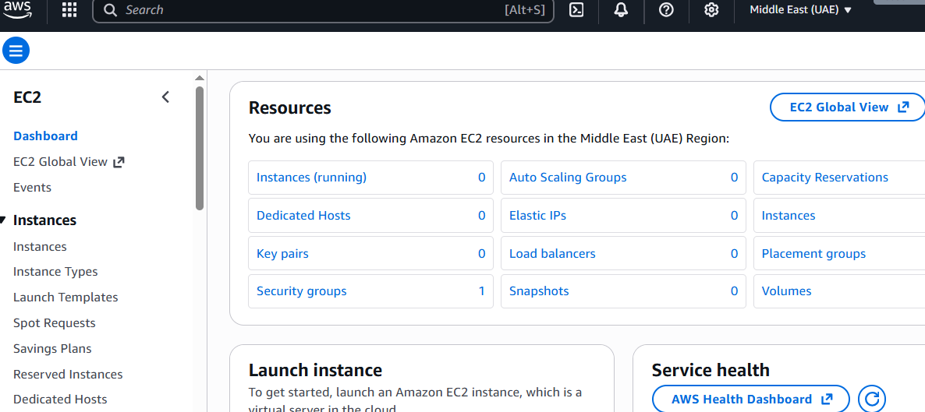
Step 2: Launch Instance Configuration
Screenshot: task4_launch_instance_config.png
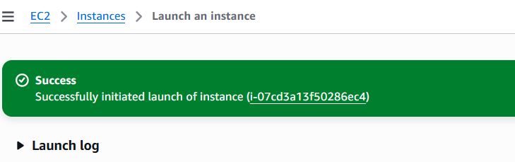
Step 3: Download Key Pair Lab8Key.pem
Screenshot: task4_keypair_download.png
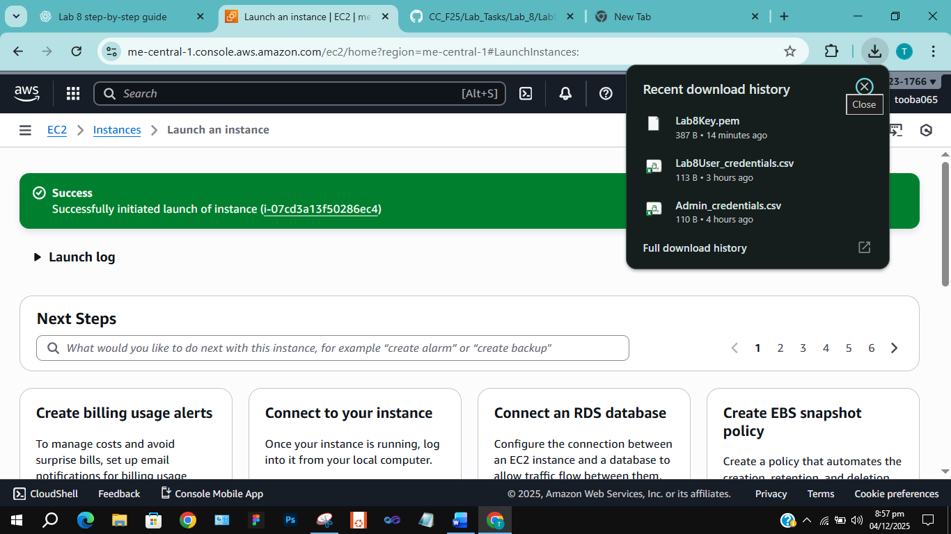
Step 4: EC2 Instance running and public IPv4 visible
Screenshot: task4_instance_running_console.png
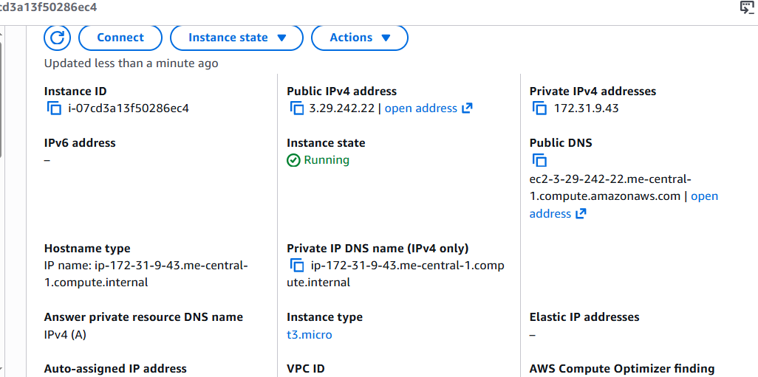
Step 5: SSH from Windows host to EC2 instance
Screenshot: task4_ssh_from_windows_to_ec2.png
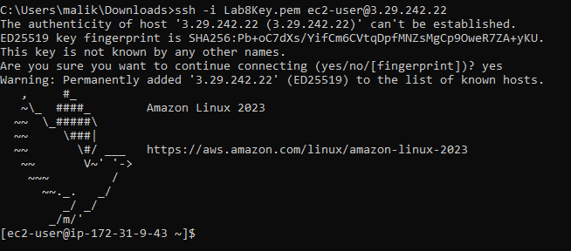
Step 6: Install Docker & Docker Compose on EC2
Screenshot: task4_ec2_install_docker_compose_started.png
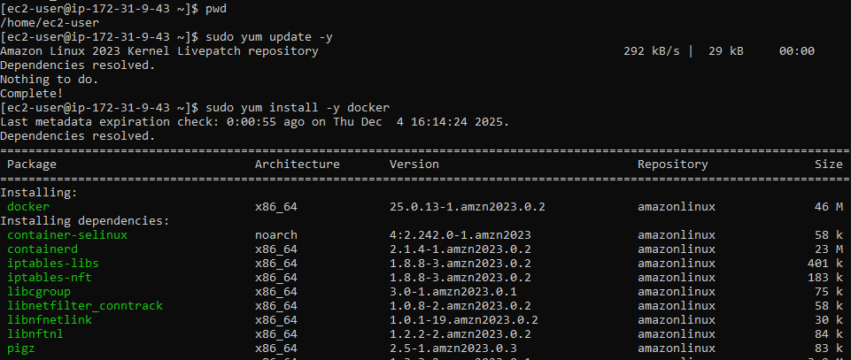
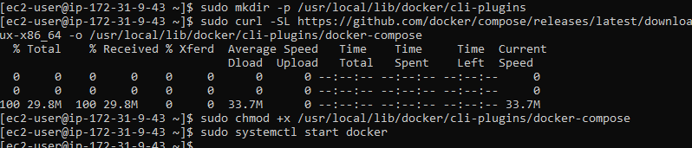
Step 7: Create/edit compose.yaml with Gitea content
Screenshot: task4_vim_compose_yaml_paste.png
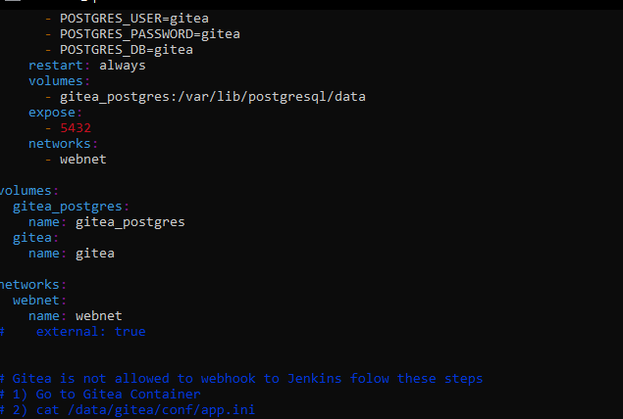
Step 8: Verify compose.yaml exists
Screenshot: task4_compose_yaml_saved_ls.png
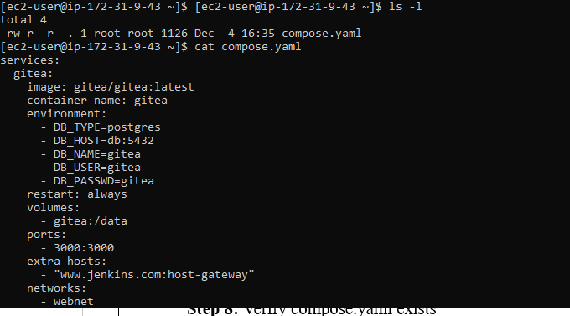
Step 9: Add ec2-user to docker group, show groups before and after reconnect
Screenshot: task4_usermod_and_groups_before_after.png
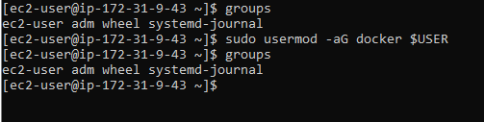
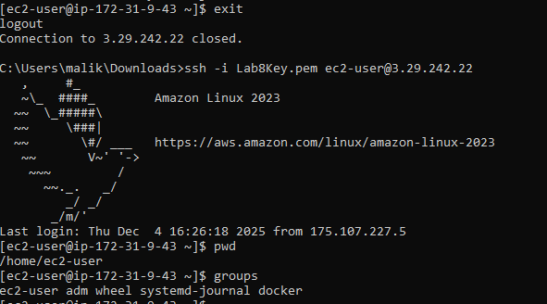
Step 10: Run docker compose up -d
Screenshot: task4_docker_compose_up.png
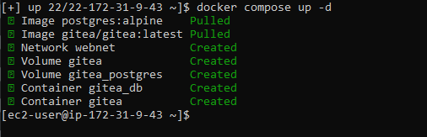
Step 11: Update Security Group Lab8SecurityGroup inbound rules to allow TCP 3000
Screenshot: task4_security_group_allow_3000.png
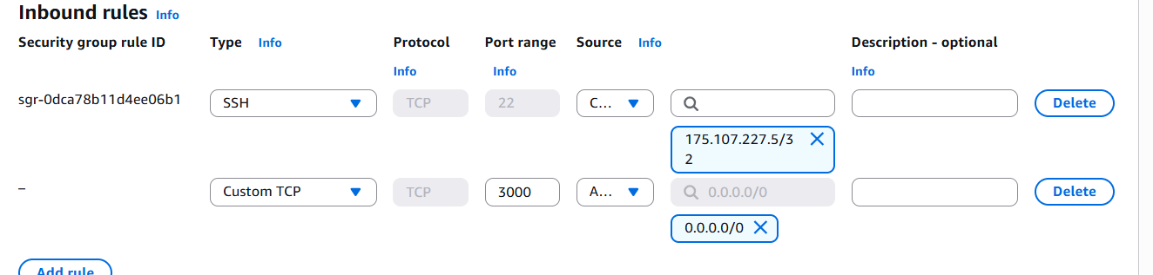
Step 12: Access Gitea installation page in browser
Screenshot: task4_gitea_install_page.png
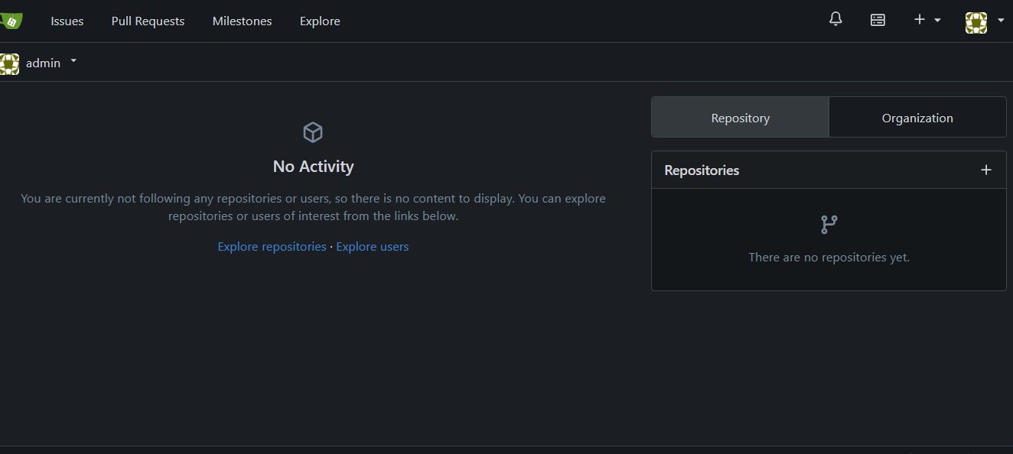
Step 13: Complete Gitea setup and create repository
Screenshot: task4_gitea_create_repo.png
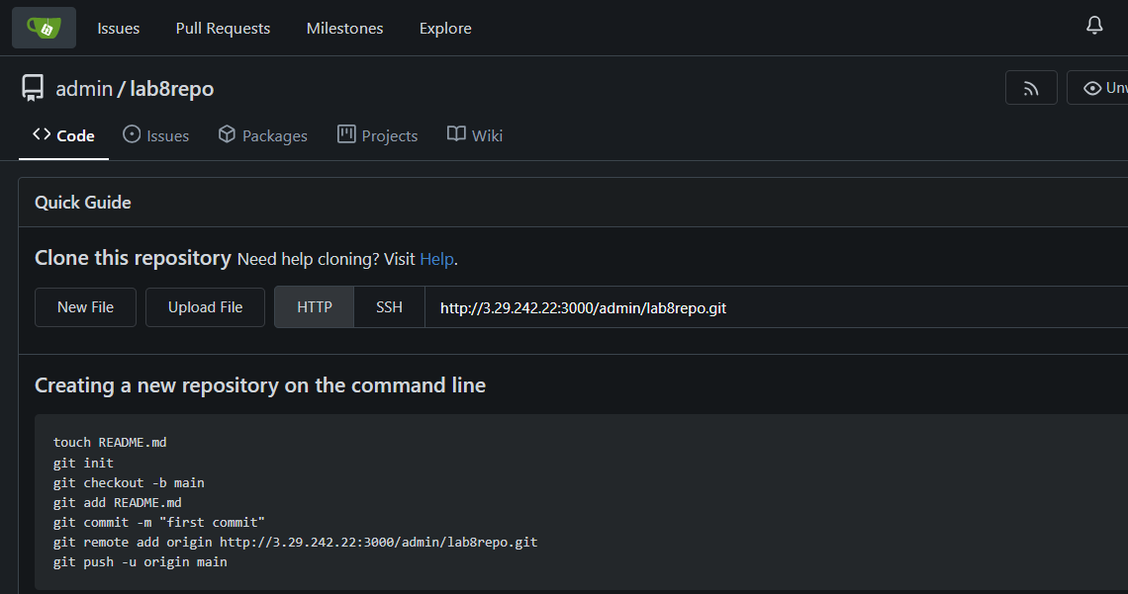
Step 14: Task 4 Summary — combined EC2, Security Group, Gitea UI
Screenshot: task4_summary.png
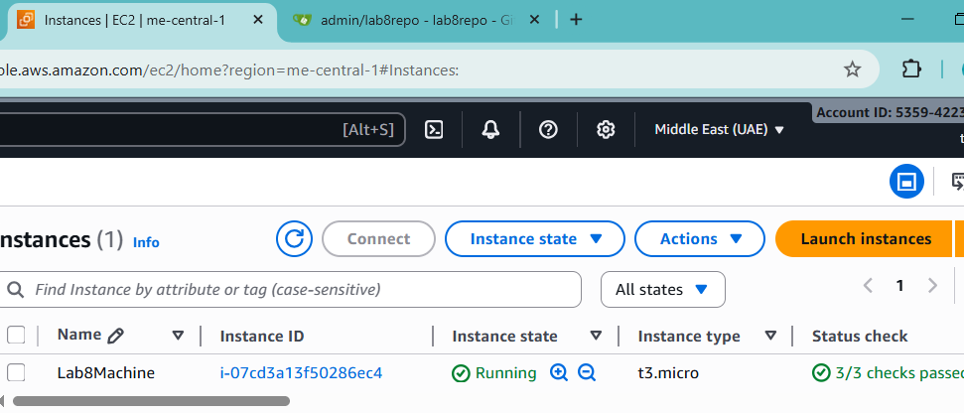

Cleanup — Remove All Resources
Goal: Terminate EC2, delete volumes, security groups, key pairs, IAM users.
Step 1: Terminate EC2 instance Lab8Machine
Screenshot: cleanup_terminate_instance.png
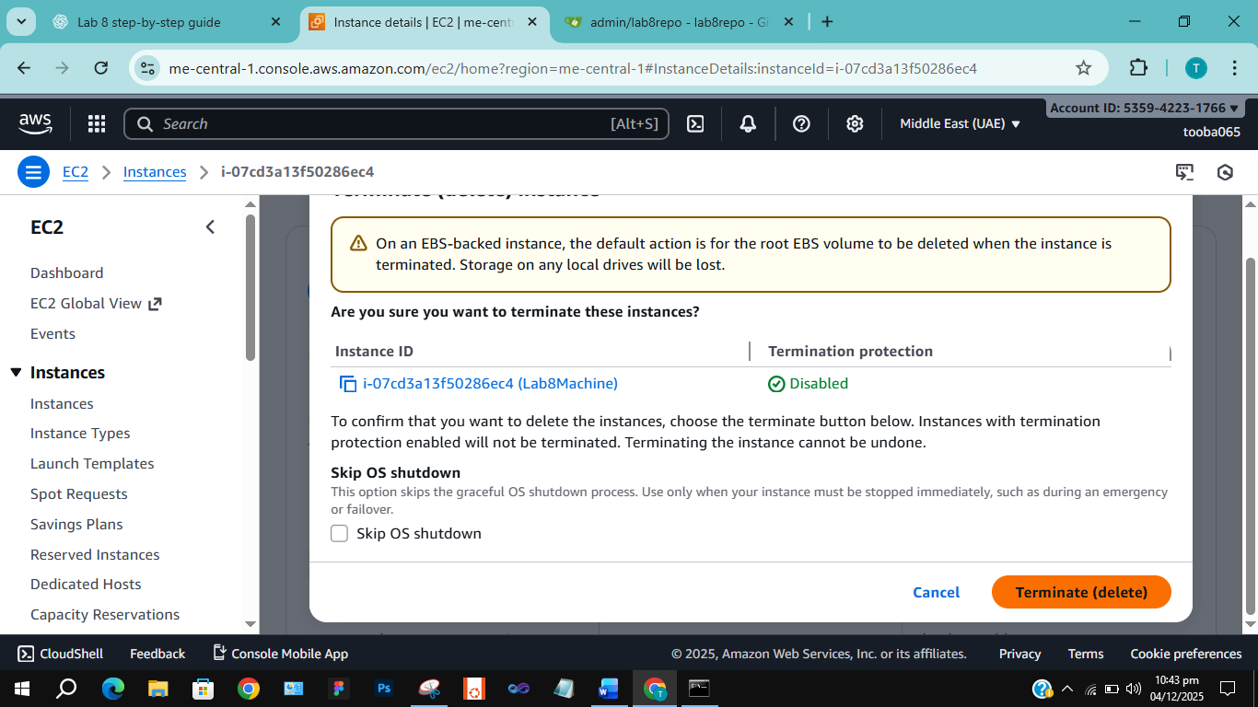
Step 2: Delete associated EBS volumes and snapshots
Screenshot: cleanup_delete_volumes_snapshots.png
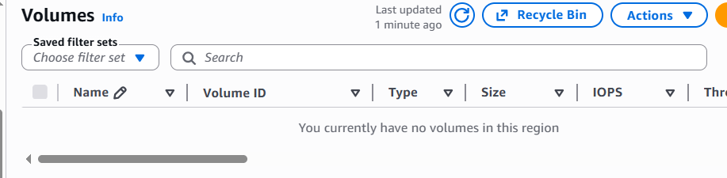
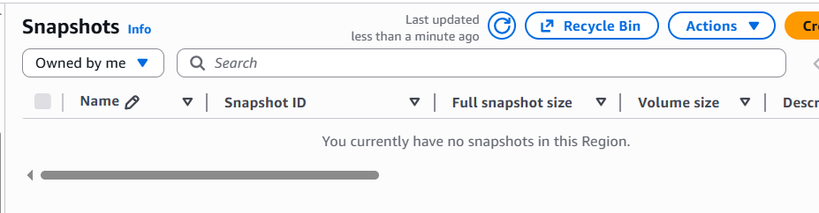
Step 3: Delete Security Group Lab8SecurityGroup and Key Pair Lab8Key
Screenshot: cleanup_delete_security_group_and_keypair.png
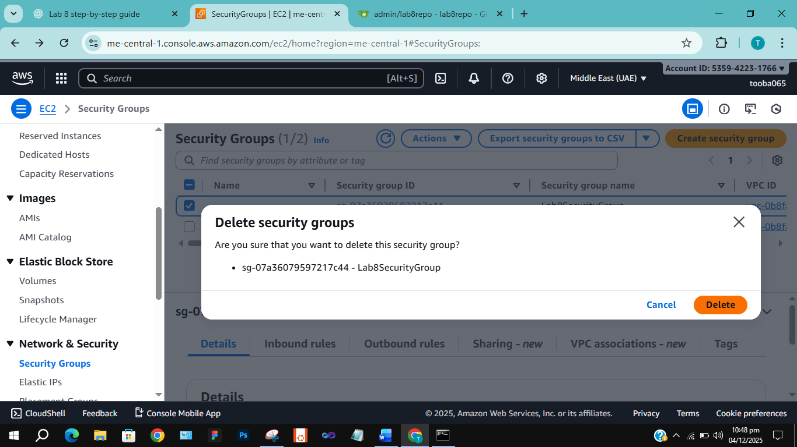
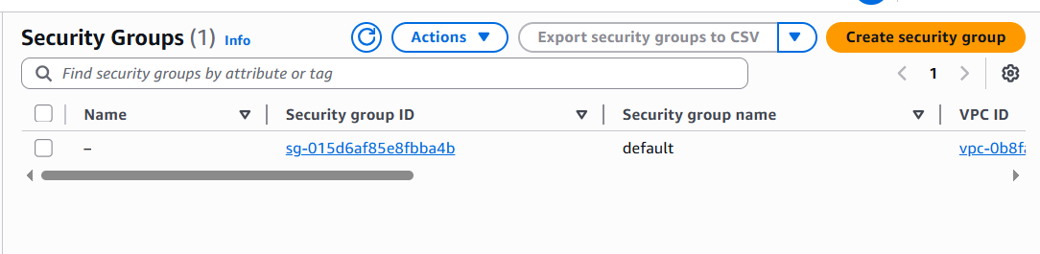
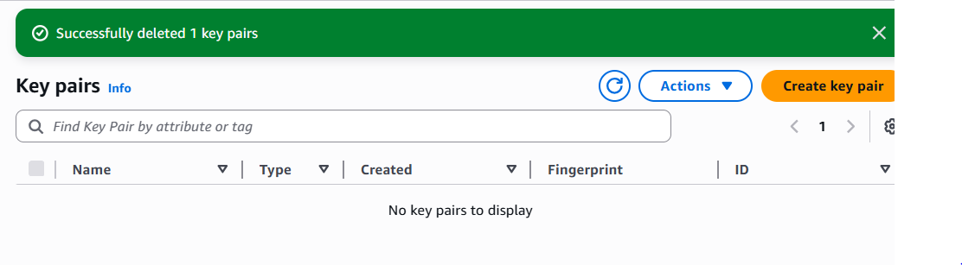
Step 4: Delete IAM users Lab8User and access keys
Screenshot: cleanup_iam_users_deleted.png
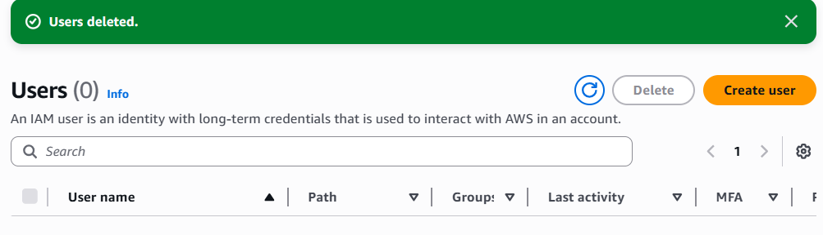
Step 5: Final cleanup summary — show billing/resources with no active resources
Screenshot: cleanup_summary.png
